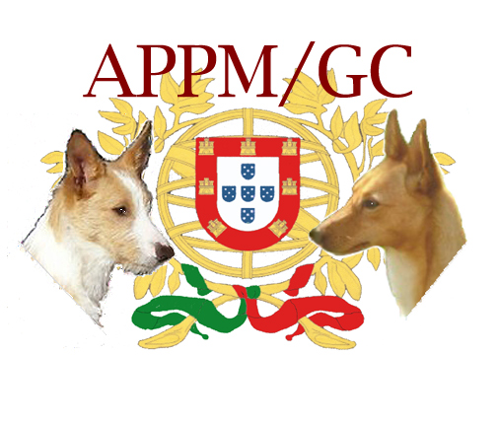
PORTUGUESE PODENGO
MEDIO & GRANDE
A primitive type dog, its probable origin lies in the ancient prick-eared dogs brought by the Phoenicians and Romans to the Iberian Peninsula in Classic Antiquity. This rustic breed adapted itself to the Portuguese geography and climate, resulting in what is nowadays the primary pack hunting dog in Portugal for large (boar/stag) and small (rabbit) game.
The GRANDE, the largest of the Podengos, was developed for deer and wild boar hunting. It will exhaust and hold down the prey and await the hunter's gun. The Grande is now very rare in its home country.
The MEDIO, or middle size, was developed for rabbit chasing, flushing, hunting and retrieval. Its hunting style includes catlike stalking and, similar to the Ibizan Hound, it often jumps above the prey before landing on or near it to flush it out of dense brush, rock crevices or burrows. It will dig if necessary to flush prey.
GENERAL APPEARANCE - Well proportioned, muscled, sound with moderate bone.(Grande size heavier body and bone) Lean 4 sided pyramid shaped head with prick ears. Tail: sickle -shaped. Over emphasis on any one feature should be strongly avoided. The Medio and Grande come in two coat textures, smooth and wire. The Podengo is a hunting dog, scars from honorable wounds shall not be considered a fault.
SIZE & SUBSTANCE The proportions of the Grande and Medio are almost square. Strong in build, heavier bone present in larger size dogs. Body length from prosternum to point of buttocks is approximately 10% longer than the height at the withers.

- GRANDE: 22" to 28" at the withers, 44 to 66 lbs
- MEDIO: 16" to 22" at the withers, 35 to 44 lbs
HEAD The head is lean with a flat or slightly arched skull. Shaped like a 4-sided pyramid, tapering towards a slightly protruding nose tip. Occipital bone is moderately defined. The stop is moderately defined. The planes of the skull and muzzle diverge, cheeks lean and oblique (not parallel).
MUZZLE – The muzzle is straight in profile; slightly shorter than the skull; broader at the base than at the tip. Lips are close fitting, thin, firm, and well pigmented.
TEETH – Large strong teeth should meet in a scissors bite.

NOSE - The nose is tapered and prominent at the tip. It is always darker in color than the color of the coat.
EYES – Almond shaped, very expressive, moderate in size, not prominent, set obliquely, color varies according to coat color from honey to brown.
Fault: Eyes of two different colors.
EARS – The ears are triangular in shape with their length greater than their width at the base. They are typically carried erect. Highly mobile, the ear can point forward, sideways, or be folded backward, according to mood. The lowest point of the base is at level of the eye.
Fault: Bent or drooping hound ears. Ears should, at minimum, lift at the base.

NECK, TOPLINE, BODY

NECK - The neck is straight, strong and well muscled. It transitions smoothly from head to body and is free from throatiness.

TOPLINE – The top line is typical of larger sight hound straight or slightly arched. Flexible.

BODY –Well proportioned body slightly longer than height at withers. Ribs moderately well sprung and well carried back. The chest reaches down to the elbow, medium width. The croup is straight or slightly sloping, broad and muscular. There is a slight tuck up.
FOREQUARTERS The shoulder is long, inclined, and strong, angulation is moderate. The fore legs are straight, lean and well muscled, with elbows held parallel to the body. The pastern joint is not prominent and the pasterns are short and strong. Presence or absence of Front dew claws immaterial. The wrists are very elastic and flexible.
HINDQUARTERS Well muscled and clean. Upper thigh long, of medium width, muscular. Moderately angulated. The rear pasterns are strong, short and straight and there are no dewclaws.
FEET Oval, neither cat footed nor hare footed. Toes long, slightly arched, nails strong and preferably dark. Pads firm.

TAIL The tail is set moderately high, thick at the base tapering to a fine point, and at rest it falls in a slight curve between the buttocks. When the dog is in motion it rises to the horizontal and is slightly curved or it may go up to vertical in a sickle shape. The hair is fringed on the underside of the wire coat tail.
Disqualification: Curled in ring touching the back.
COAT There are two types of coat:
- Smooth coat which is short and very dense with undercoat present.
- Wire coat which is rough and harsh, not as dense as the Smooth coat, and without undercoat. The Wire coat produces a distinct beard.
The coat is to be shown in a natural state, the face and feet may be trimmed, but no other trimming or shaving is to be condoned. The coat does transition as the new coat grows in the old coat dies and come out in large sections starting at the base of the neck, down the center of the back and then down the sides of the body. The coat is not to be penalized in this state of change.
Fault: Silky or soft coat.
COLOR Preferred: Yellow & white or fawn & white of any shade or primarily white with patches of any shade of yellow or fawn.
The following colors are also acceptable Black or shades of brown/red, with white patches or white with patches of black or brown.
Fault: Brindle and solid white.

GAIT Side Gait is of a typical larger sight hound balanced front and rear. Front action is straight and reaching moderately forward. Going away, the hind legs are parallel and have moderate drive. Convergence of the front and rear legs towards their center of gravity is proportional to the speed of their movement, giving the appearance of an active agile hound, capable of a full day’s hunting.
TEMPERAMENT They are an intelligent, independent, affectionate, alert breed, however they can be wary with strangers and this should not be considered a fault in the judging process.

FAULTS (minor fault)

- Eyes of two different colors.
- bent ears.
- Silky or soft coat.
- Brindle and solid white.

DISQUALIFICATION

TAIL- Curled in a circle touching the back.
EARS –drooping hound ears
SIZE - Under 16”

NOTE – there is a choice here –1 - take out the top dq cause we never originaly had one and we have enough dogs that I don’t think it will be needed - only leave the under because we need to have separation from pequeno. As a dq and drop the top as a dq. Or Leave it as 1 inch over At the top – the committee feels that getting rid of the top DQ AND LEAVING THE BOTTOM MAKES THE MOST SENSE.

DRAFT WITH CHANGES.
Visit our website:
www.podengo-mediogrande.com
Diana McCarty, President
Dmcarty100@yahoo.com
763-682-4699

