THE PODENGO GRANDE AND THE IBIZAN
By Diana McCarty
Compare selected items of the breed standards.

When people first see Hanna or Libby of one of the other Grande’s, many times their first thought is, “it’s an Ibizan”.
While they share many traits with each other and the other primitive sight hounds of the Mediterranean region there are some specific differences in particular in head shape and ear size, weight, bone, and gait.
First the head shape – in the first set of pictures you can see a couple of differences. The muzzle of the podengo on the left is more blunt than the more sharply tapered Ibizan. The profile shows the Ibizan has a much leaner head, less underjaw, and of course the “very slight Roman convex”. At first glance the ears look similar however closer examination and knowing that the Ibizan in this photo is a mature dog while the Podengo is a juvenile would yield a larger ear on the Ibizan.
Also evident is the difference in the neck – ‘straight, strong and well muscled,’ compared to the Ibizan’s “long, slender, slightly arched and strong”.
Keeping in mind that the Ibizan was hunting rabbits and the Podengo Grande Boar, a heavier body would be needed for the individuals in the pack to contain the boar than they would need hunting rabbits. Hence the difference in weight and the difference between ‘Lithe and racy’ in the Ibizan standard and “Well proportioned muscled, sound with moderate bone”

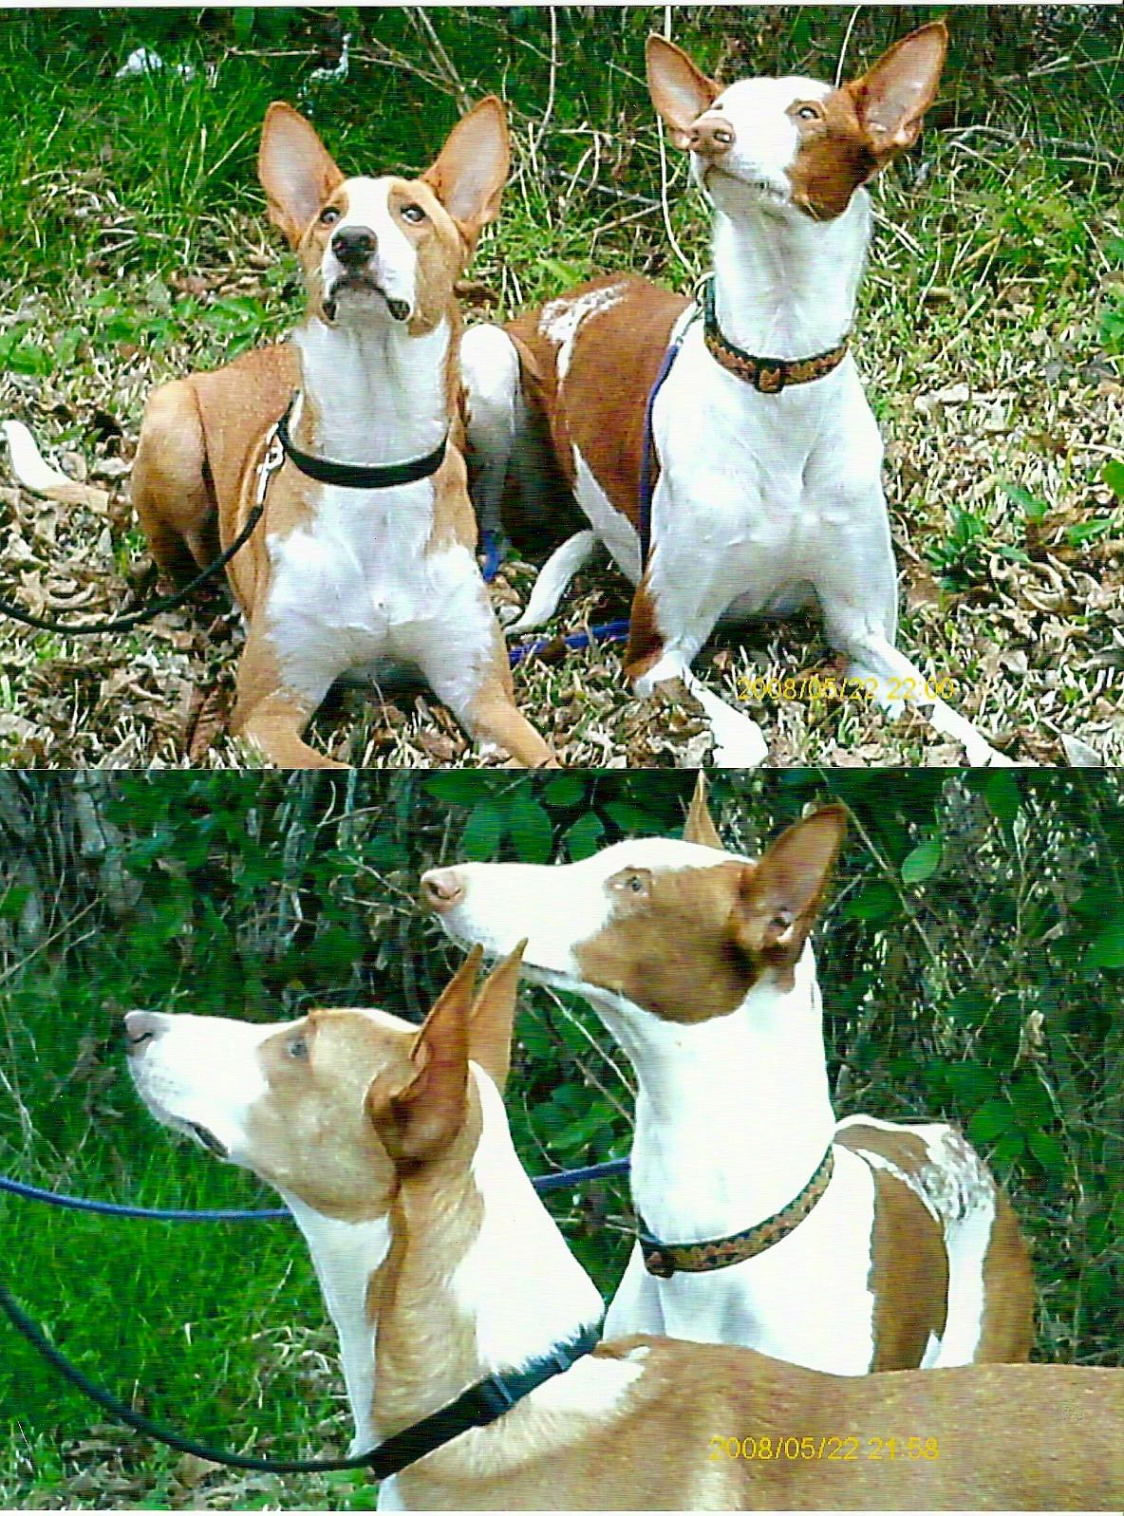
Photo from Lorrie Niskala

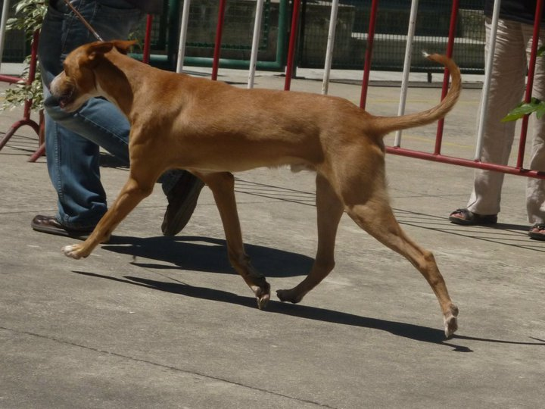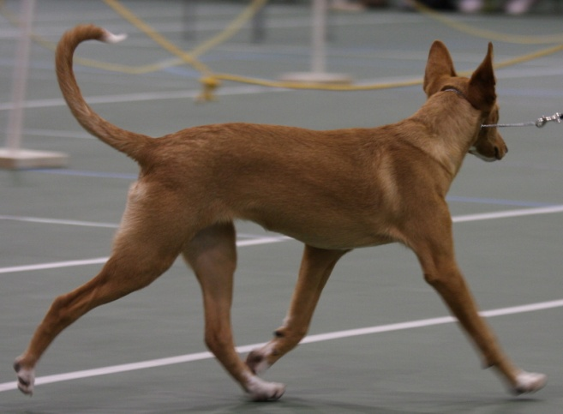
Moving you can see the clear reach forward from the shoulder as compared to the suspended trot with joint flexion more commonly seen in the Ibizan.
Thanks to Wendy Anderson and Jeannie Jones Armstrong for photo suggestions for the Ibizan moving photos.
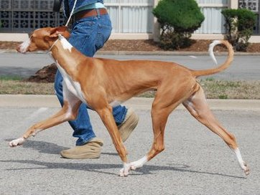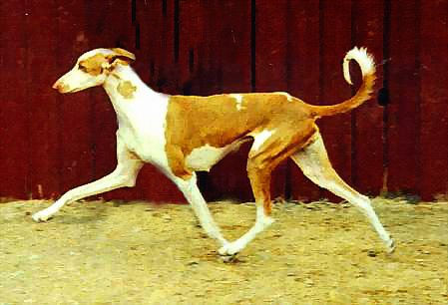

SELECTED SECTIONS OF THE STANDARDS
GENERAL APPEARANCE  The Ibizan’s clean-cut lines, large prick ears and light pigment give it a unique appearance. A hunting dog whose quarry is primarily rabbits,  this ancient hound was bred for thousands of years with function being of prime importance. Lithe and racy, the Ibizan possesses a deer like elegance combined with the power of a hunter. Strong, without appearing  heavily muscled, the Ibizan is a hound of moderation. With the exception of the ears, he should not appear extreme or exaggerated.  In the field the Ibizan is as fast as top coursing breeds and without equal in agility, high jumping and broad jumping ability. He is able to spring to great heights from a standstill. | GENERAL APPEARANCE  Well proportioned muscled, sound with moderate bone.  Wedge shaped head with prick ears. Tail: sickle -shaped.. The Medio and Grande come in two coat textures, smooth and wire. The Podengo is a hunting dog; scars from honorable wounds shall not be considered a fault.  The GRANDE, the largest of the Podengos, was developed for deer and wild boar hunting. It will exhaust and hold down the prey and await the hunter's gun. The Grande is now very rare in its home country.  The MEDIO, or middle size, was developed for rabbit chasing, flushing, hunting and retrieval. Its hunting style includes catlike stalking and, similar to the Ibizan Hound, it often jumps above the prey before landing on or near it to flush it out of dense brush, rock crevices or burrows. It will dig if necessary to flush prey.
SIZE & SUBSTANCE  Size--The height of dogs is 23½ inches to 27½ inches at the withers.  Bitches are 22½ to 26 inches at the withers. There is no preference for size within this range. Sizes slightly over or under the norms are not to be regarded as demerits when other qualities are good.  Weight--Average weight of dogs is 50 pounds; bitches, 45 pounds.  Proportion--Slightly longer than tall. Substance--The Ibizan possesses  clean, fine bone. The muscling is strong, yet flat, with no sign of  heaviness | SIZE & SUBSTANCE  The proportions of the Grande and Medio are almost  square. Strong in build, heavier bone present in larger size dogs. Body length from prosternum to point of buttocks is approximately 10% longer than the height at the withers.  ● GRANDE: 22" to 28" at the withers, 44 to 66 lbs  ● MEDIO: 16" to 22" at the withers, 35 to 44 lbs
HEAD  Long and narrow in the form of a sharp cone truncated at its base.  Finely chiseled and extremely dry fleshed. The muzzle is elongated,  fine, and slender with a very slight Roman convex. | HEAD  The head is lean with a flat or slightly arched skull. Shaped  like a 4-sided pyramid, tapering towards a slightly protruding nose tip.  The stop is moderately defined.  The planes of the skull and muzzle diverge, cheeks lean and oblique (not  parallel).
NECK,TOPLINE, ,BODY  The neck is long, slender, slightly arched and strong, yet flat muscled. The topline, from ears to tail, is smooth and flowing. The back is level and straight. The chest is deep and long with the breastbone sharply angled and prominent. The ribs are slightly sprung.  The abdomen is well tucked up, but not exaggerated. The loin is very slightly arched, of medium breadth and well muscled. The croup is very slightly sloping. The tail is set low, highly mobile carried in a sickle, ring, or saber position, according to the mood and individual specimen. | NECK,TOPLINE,, BODY  NECK - The neck is straight, strong and well muscled. It transitions smoothly from head to body and is free from throatiness.  TOPLINE – The top line is straight or slightly arched.  BODY –Well proportioned body slightly longer than height at withers. Ribs moderately well sprung and well carried back. The chest reaches down to the elbow, medium width. The croup is straight or slightly sloping, broad and muscular. There is a slight tuck up.
GAIT  An efficient, light and graceful single tracking movement. A suspended trot with joint flexion when viewed from the side. | GAIT  Side Gait is of a typical larger sight hound balanced front and  rear. Front action is straight and reaching moderately forward.

